NEARER Vision Day - 14th August 2016 - Report
1 Dwelling in the Word and Prayer - SHARON
We read and shared Romans 15:1-13

WORDS THAT IMPACTED US AND OUR RESPONSES -
Who are our neighbours?
How do we do good?
Bearing with the weak.
Accepting people as they are - as Christ did - this can only come from God and requires endurance and a change in attitude and it is not easy.
It requires putting ourselves second, others are the focus - this is hard and costly.
We do not live for ourselves.
People will try to take advantage of us.
We are ‘singing’ with our lives.
We need to trust God and He will fill us with hope.
This can be a burden and not a joy.

2 Setting the Framework - STEPHEN
What is a Fresh Expression of church?
The black dots indicate all the people in the context in which we live. The red dots indicate the Christians.

If the Christians huddle together, as in the left-hand picture, if they spend all their time being together, socialising together, then they have little contact with the people in their context.

If the Christians get involved in their context, as in the right-hand picture, if they are present and active in their communities, then they have much more contacts and opportunities to build relationships, find ways of serving and of sharing their faith.
The NEARER group wants to be like the right-hand picture. This was agreed by all present to be our aim.

What does NEARER do? What does NEARER not do?
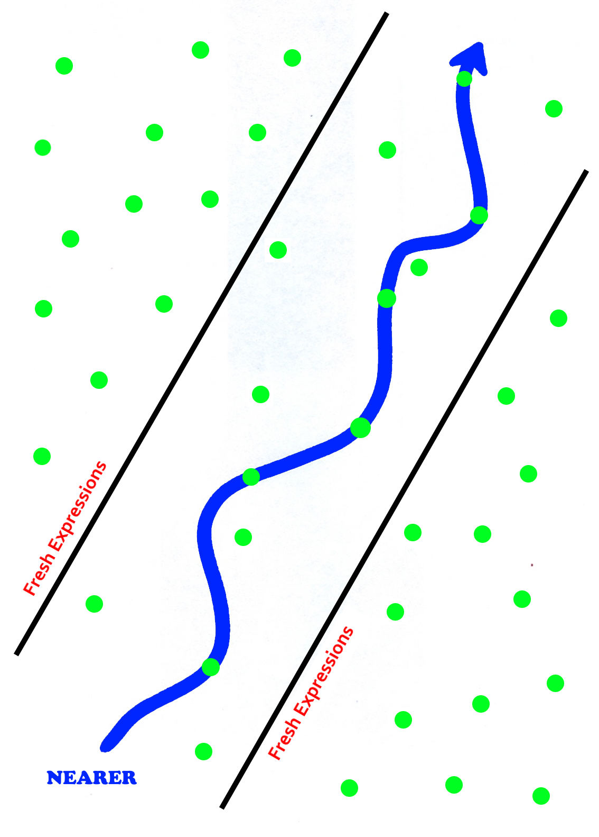In this picture the green dots are all the things churches can do as ways of living out their faith.
The two lines marked ‘Fresh Expressions’ shows the selection of these ways of being / doing church that are consistent with being a Fresh Expression of church.

Within this selection NEARER has embraced a few they feel are right for us and our context. This is a process of experimentation, trial and error, and discernment. It is also dynamic. We are constantly looking to see where God is working and to join Him in what He is doing.

NEARER DNA and the Seven Sacred Spaces
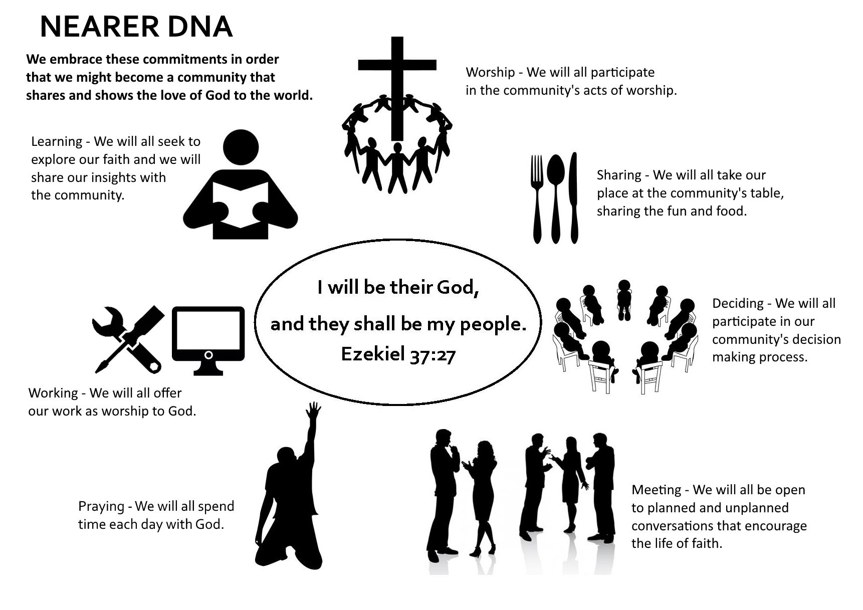

We reflected on this image and asked ourselves if this still described what we feel NEARER is.
We agreed that it was but that it needed some changes. We wanted to emphasise that all activity is something we can offer as worship to God, so we should change the word ‘work’ to ‘activity’ in order to reflect this.

We agreed that keeping a spiritual journal about how well we are embedding these activities in our everyday lives was not to be a compulsory activity, but that those who felt it was helpful to them would embrace this discipline.

We reflected that the more we prayed asking God to give us opportunities to share our faith, the more these seemed to happen!

A weakness in this picture is that it does not explicitly show the missional focus of our community. This amendment was offered for discussion.

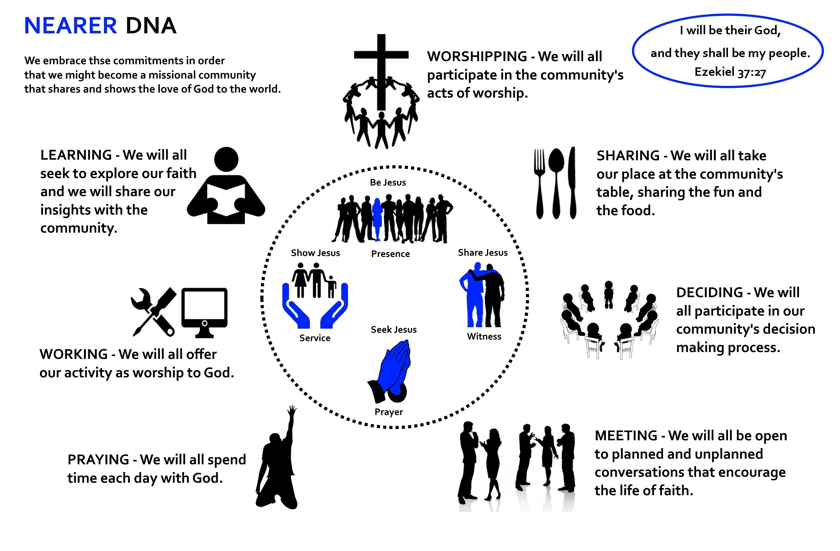
This image tries to show that we embrace the NEARER DNA in order to create a community that will help us to be empowered, encouraged, inspired, and challenged to live missional lives.

In our missional lives:
- we will ‘Seek Jesus’ in our praying for others;
- we will seek to ‘Be Jesus’ in our presence and involvement as opportunities are opened up;
- we will ‘Show Jesus’ through acts of loving service to those we are in relationship with;
- we will ‘Share Jesus’ in acts of witness as these arise.

No final decision was made about the graphic, although it was generally perceived to be a more accurate statement of where we are now. We will continue to explore this in the coming weeks.

We agreed that NEARER is not a ‘Worship First’ approach to mission.
We agreed that NEARER is not primarily event based.
We agreed that NEARER feels called to a ‘Loving and Serving First’ approach.

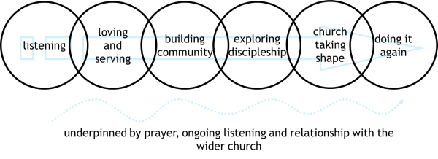
Individually and as a group we seek to show the love of Jesus in practical and spiritual service to our community - which is an end in itself.

Through praying and looking for the activity of God in the relationships built through this service we identify and respond to opportunities to introduce faith.

We then accompany those who respond with openness and together with them we find a way to be church that is appropriate for them and faithful to the Christian tradition.

3 Being a Christian Community - Why and How? [10 minutes] - JILL
We explored the challenge of community.
If you haven’t yet been disappointed/upset by someone/something in NEARER, you will be!
How do we deal with the upsets we will inevitably cause to each other?
Forgiveness, willingness to change, not spreading the poison - biblical principles for handling conflict.
We read Colossians 3:12-14.
“Therefore, as God’s chosen people, holy and dearly loved,
clothe yourselves with compassion, kindness, humility, gentleness and patience.
Bear with each other and forgive one another if any of you has a grievance against someone.
Forgive as the Lord forgave you.
And over all these virtues put on love, which binds them all together in perfect unity.”

We had a time of personal silent meditation on the question ‘What does this mean in PRACTICE?’

We prayed a communal prayer of repentance for the ways in which we have knowingly/unknowingly hurt one another.

We read the Colossians text together again as an act of commitment.

4 The ‘Clearing the Air’ responses - PETE
PRAYER
- What COULD we do?
Just do prayer at every meeting
Not pray together at all.
Prioritise prayer and make it central.
Continue to have specific times and events for prayer.
Do prayer and worship every week or at another meeting.

- What SHOULD we do?
Communicate about our events more clearly so everyone knows exactly what to expect.
Be flexible.
Pray specifically and at targeted times.

- What WILL we do? Who, When, Where, What, and How?
Stephen will try to communicate more clearly the purpose of each event so people know what to expect.
We will all continue to make prayer a priority.
We will have times of focussed prayer on a regular basis - we will try to make these accessible to all NEARER members.
Those who feel they would like to will seek to meet in smaller groups (pairs, triplets) to pray together.

CHAPEL 12:00 to 12:15
We attended the Mercian Community’s mid-day prayers in their chapel.

LUNCH 12:15 - 12:45

5 The ‘Clearing the Air’ responses - PETE \cont.
WORSHIP
- What COULD we do?
Praise God in singing.
Meet on Sundays.
Find creative ways to express worship.
Celebrate/Take communion.
Have an agapé/fellowship meal.
Have a separate event.
Have a ‘service’, some form of church.
Join clubs/groups.
Go to the Café on the Corner.
Worship/meet with God as a community.
On Wednesday evenings (some or all) we could worship (for part/all of the time).
How do we demonstrate community worship to not-yet-Christians?
When do we know it is an appropriate time to invite someone to an act of worship?
Re-merge on Weds.

- What SHOULD we do?
Communicate clearly.
Understand that worship is much more than just singing.
Continue to have moments of worship in our events but to make sure these are appropriate to those who are there.
(At least for now) meet as one group on Wednesdays

- What WILL we do? Who, When, Where, What, and How?
Venues not resolved – some preference for continuing in homes.

WORK
- What COULD we do?
Do things as sub-groups of NEARER.
Be in different communities.
Care about our communities.
Pray for each other’s activities.

- What SHOULD we do?
Be involved in our community, including community events. .

- What WILL we do? Who, When, Where, What, and How?
NEARER will always be present at Birstall Community events.
Should not rely on a few members of NEARER. As many members as possible – just being.
Open to all – just being Jesus, being present (reference to diagram above was made) is enough

MEETING/PRESENCE
- What COULD we do?
Listen to the input/opinions of those who are not 100% involved in NEARER
Make all NEARER activities open to all.
Have a ‘talking token’ to make sure everyone gets a chance to speak.
Take responsibility individually for how we speak.
Stimulate the church’s activities.

- What SHOULD we do?
We don’t try to do everything ourselves. We refer people to outside events that are appropriate for them e.g. ALPHA.
Continue to work with other Christian groups/churches.
Manage discussion times better.
Include times of silence in our discussions so that people who need that time can formulate their thoughts.
Respect each other’s’ opinions.
Listen to each other
Take responsibility for not talking too much.

- What WILL we do? Who, When, Where, What, and How?
(To be decided.)
DECIDING
- What COULD we do?
Meet on Hallam Fields (Care Home/Nursery).
Listen to everybody’s opinion all the time.

- What SHOULD we do?
Listen to all communities we are involved in, not simply NEARER.
Share any community feedback we receive about NEARER.
Decide by consensus as far as possible and for all major decisions (whilst recognising NEARER now has five pioneers (Jill, Gill, Peter, Stephen and Sharon) who will act as overall leaders.
Keep prayerfully considering our focus/direction – keeping Hallam Fields in mind (note made of possible venues).

- What WILL we do? Who, When, Where, What, and How?
Stephen will circulate the ‘Growth Fund Annual Report’ to all members of NEARER. This report (from February 2016) contains some feedback on NEARER from the local community.
All to continue to inform group decision making but recognising Stephen & Sharon’s and other Pioneers leadership role.

LEARNING
- What COULD we do?
Learn not to be rigid.
Not cling to the past.
Brainstorm.
Be allowed to make mistakes/experiment.
Welcome comment/feedback - and be aware of the difference between comment (given to help) and criticism (given to chide).
Share knowledge that leads to transformation and helps us act differently.

- What SHOULD we do?
Give opportunities for everyone to lead/be involved.
Keep learning.
Include different ways of learning.
Recommended that we should work in teams of at least two.
Share our learning with all, including those not in NEARER.
- What WILL we do? Who, When, Where, What, and How?
Offer everyone who wants to do it the opportunity to lead, but do this in pairs/ small groups so that we learn from one another.

SHARING
- What COULD we do?
Share our lives outside of NEARER meetings.
Make sharing a big part of what we are.

- What SHOULD we do?
Share out the responsibility for hospitality.
Organise the sharing of food better to avoid waste.
Carry on with fun and food.

- What WILL we do? Who, When, Where, What, and How?
Meet every Wednesday evening but vary the programme.
Organise who will bring what when we eat together so that food is not wasted.

6 Act of Worship - ANDRZEJ
We were led in an act of worship that focussed upon the idea of change, letting go, giving thanks, and moving on.

7 Affirming Exercise - GILL
We took the opportunity for each person in the group to be affirmed by everyone else as a way of expressing our belief that everyone is important and valued in NEARER.

